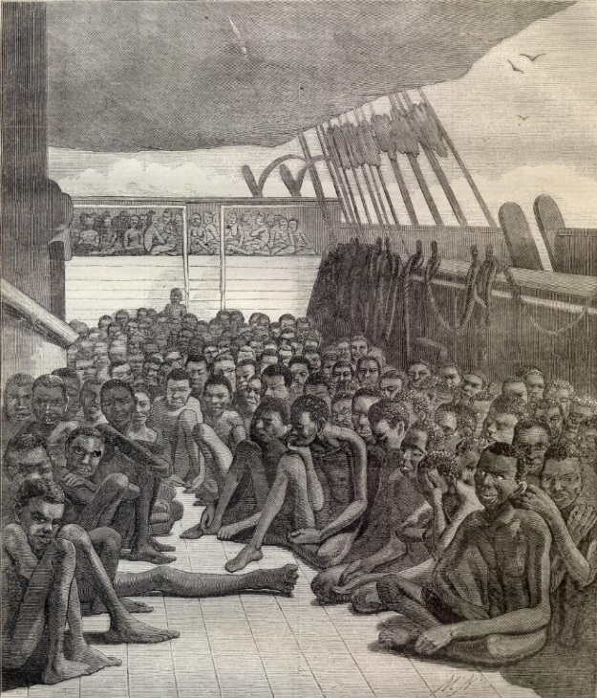
Dear Diary,
I sit, surrounded by people not six inches away, underneath the deck of a boat. I stare at the bodies-rows and rows of bodies. Some left us because of disease, others old age. Holding my breath is pointless, the acrid ___2___ never goes away and even when I do get off this ship, I will still remember that distinctive scent. The groans grow so loud that I cover my ears and try to muffle the sounds with my own singing. Last night I sang until my body passed out from exhaustion and I could only hope that I would make it until the next day. I’ve become so accustomed to tears constantly wetting my face that it would feel odd not to cry. The cycle makes this seem normal. Maybe that is why I continue to cry- stopping would break the cycle and I would have no daily ritual to follow.
Some days I wonder why I’m kept down here. I am so young compared to the rest of us. Yet the others and I are still hidden as the white men’s dirty secret. When they feel the need to be entertained, the secret is divulged. They force us onto the deck, group by group, to dance. The winter air is refreshing at first, but then I cannot stop shivering and I don’t want to move. It is so cold and my fingers hurt from frostbite. We are humiliated while at our lowest points. Our hope and dignity disappears behind the crack of a whip. The red ___8___ are everlasting mementos of our masters’ cruelty. I used to dream of mutiny, revolting against the people who kept us aboard. Then I wonder, what about the ones who die, are thrown overboard, or executed? Who shall act as our providence and save us from such a death? Only those who have endured this would side with us and surely we would lose. Why had this happened? Were they simply punishing us for our race?
Today, I looked at skin in a way I never did before. It disgusted me. I stared down at my arms and legs. They were the tint of mud, stained like dirt, the color of a moth or rotting potatoes. It was the cause of my pain. I was angry- not only at skin, but also at my parents, the white men that control this world, and everything else I could think of. If I weren’t black I wouldn’t be sitting in this dark abyss, sweating from the others’ body heat in the middle of winter. I wouldn’t be fed this slop, using an overflowing bucket for a restroom, or dying slowly at such a young age. I wouldn’t have been separated from my parents. I wouldn’t be here now- afraid, lonely, and waiting to arrive at a destination I’m unsure of. The loneliness makes me miss everyone- even the people I despised. I just want to feel safe. I miss my family and friends and I cannot bear to think that they are going through the same things I am right now.
I have never loved my brother more than I do now. Abdu, I pray to see you again one day. Grandmother Etana, I wish with all my tears to be in that little hut with you again. You all were my security blanket. Here I have none and everything is so overwhelming. I am not sure I can take it any longer. I have awful nightmares and I always wake up with sweat and tears dripping off my body. At least I had one good dream while I was here. I dreamt of Africa, and it was beautiful! I saw everyone again. I could no longer taste blood on my tongue, hear the screaming and groaning of insane elders, or reach out to touch a dead person’s cold and rigid skin on any side of my body. For once, there was grass instead of water licking a boat and tossing it around. I kissed the ground. I kissed brother, mom, dad, and grandmother. It was a perfect world. My life had gone right and I’d long since forgotten of these scaring memories. Yet then, I awoke that night to see an old man dying of a heart attack. His sparkling blue eyes turned grey as his spasms came to a cessation.
Would I have been better off shot by one of the white men? Would I rather stay here and wilt like a dying rose? Right now I do not know why I make myself endure this torture. My life will never be the same after living this way, so why even try to live? I cannot live a life wanting to kill myself, too cowardly to perform the deed. Yet, isn’t it cowardly in itself to hang oneself or fast until your body gives up. Maybe it is braver to undergo the suffering, but my body can’t take much more. All I know is someday I’ll be free- even if it is among the dead I wander, I won’t be here.
Asha Larai died on December 13th 1624, her hopes still high.

Answer the questions below. ↓
Unit 1: Reading assignment 1.4

Assignment 1.4. A: Read the text “Dear Diary”.
Assignment 1.4 B: Answer the following questions in English.

- Mention two reasons why some people are not on the ship any longer.
__________________________________________________________________________

- Choose the missing word in line 8.
- Feeling
- Sight
- Smell
- Touch

- Why does the girl sing?
- Because she loves singing
- Then she won’t hear others moan
- Because she tried to pass out
- So she falls asleep more easily

- Why does the girl think it’s strange not to cry?
_________________________________________________________________________

- What makes this girl different than others on the boat?
- She is white
- She is a girl
- She is black
- She is young

- Why are the people forced onto the deck?
__________________________________________________________________________

- “Our hope and dignity disappears behind the crack of a whip”. (lines 24-25) What does this mean?
____________________________________________________________________________________________________________________________________________________

- Fill in the missing word in line 25.
- Marks
- Blood
- People
- Eyes

- Why does the girl feel angry? Mention at least two things.
__________________________________________________________________________

- What does the loneliness do to the girl?
__________________________________________________________________________

- Describe the good dream the girls once had.
____________________________________________________________________________________________________________________________________________________

- What was the first thing the girl saw when she woke up from her good dream?
____________________________________________________________________________________________________________________________________________________

- “My life will never be the same after living this way, so why even try to live”. (line 63) Explain what the writer means by this.
_______________________________________________________________________________________________________________________________________________________________________________________________________________________________________

