Combating Modern Slavery: The '3P' Paradigm of Prevention, Victim Protection, and Prosecution
POSTED BY KARI JOHNSTONE
JANUARY 13, 2015
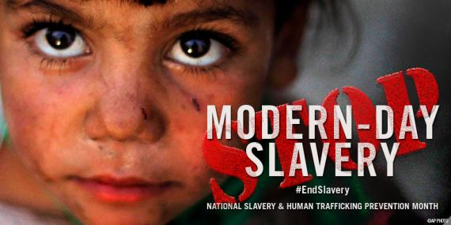
National Slavery and Human Trafficking Prevention Month 2015
Today, millions of men, women, and children are victims of human trafficking. Modern slavery can take many ___1___. Children are made to be soldiers, young women and teens are ___2___ and forced into prostitution, and migrants are exploited and compelled to work for little or no pay. Human trafficking is a crime that tears at our social fabric and debases our common humanity.
Modern slavery occurs in countries throughout the world -- and in communities across the United States. To raise ___3___ of this issue in our country, President Obama proclaimed January as National Slavery and Human Trafficking Prevention Month, culminating in the annual celebration of National Freedom Day on February 1.

We have come a long ___4___ in the past 15 years: 166 states are now party to the Palermo Protocol, which introduced a comprehensive approach to combating modern slavery through the“3P” paradigm of prevention, victim protection, and prosecution. More than one hundred countries have passed anti-trafficking laws, and many have established specialized law enforcement units, set up trafficking victim assistance mechanisms, and launched public awareness campaigns aimed at combating this crime. But we still ___5___ many hurdles and have a considerable way to go before human trafficking is eradicated around the world.
We know that this crime ___6___ every country in the world. It is estimated that more than 20 million people are victims of human trafficking, generating $150 billion in illegal profits per year. The United States is not exempt and we are the first to acknowledge that all governments, including our own, must do more. The State Department’s Trafficking in Persons Office is working collaboratively with governments around the world to understand and address the evolving nature of this crime, which demands a universal respect for human rights, as well as strong rule of law and stable democratic institutions. Partnerships with civil society and ___7___ of human trafficking are key not only to preventing political crises, but also to enabling States to act quickly and efficiently. We have seen that human trafficking is a clear national security threat as the world witnessed ISIL’s horrific enslavement of Yezidi women and girls in Iraq and Syria, and the kidnapping of women and young girls by Boko Haram from Chibok, Borno State. Both ISIL and Boko Haram have proudly professed practicing slavery, justifying their actions with a perverse interpretation of Islam.
As we fight to end modern slavery, we echo what President Obama said, “we stand with the survivors, advocates, and organizations dedicated to building a world where our people and our children are not ___8___ Together, let us recommit to a society where our sense of justice tells us that we are our brothers' and sisters' keepers, where every person can forge a life equal to their talents and worthy of their dreams.”
Today, every person can take action to help eliminate human trafficking. You can begin by learning about this issue. Watch Under Secretary Sarah Sewall and read our list of 20 ways you can help fight trafficking.
At home and around the globe, we must continue to fight against human trafficking.

Unit 6: Reading assignment 6.1 Modern Slavery

Assignment 6.1 A: Read article “Combating Modern Slavery: The '3P' Paradigm of Prevention, Victim Protection, and Prosecution”.

Assignment 6.1. B: Which of the following words fit the gaps in the text best?

- A. people
B. forms
C. chances
D. ways

- A. beaten
B. discriminated
C. changed
D. challenged

- A. security
B. awareness
C. ignorance
D. misunderstanding

- A. journey
B. change
C. experience
D. way

- A. neglect
B. show
C. face
D. hide

- A. affects
B. changes
C. challenges
D. continues

- A. suspects
B. survivors
C. victims
D. saviors

- A. changed
B. scared
C. broken
D. for sale
Assignment 6.1. C: Think about the different forms of slave labor hundreds of years ago, and the different ways of slavery that still occurs today. Create your own venn diagram showing the differences and similarities between slavery back then, and slavery today. Use http://creately.com/Draw-Venn-Diagrams-Online to create your own venn diagram and insert the diagram into this document.

