Unit 5 Martin Luther King Jr assignment 5.1
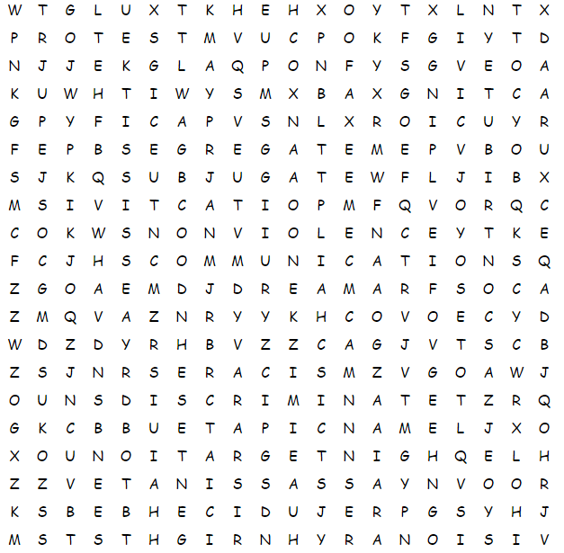
Assignment 5.1. A Find the new vocabulary in this word puzzle and learn them for the test at the end of this course.

ACTIVISM | ASSASSINATE | BOYCOTT
CIVIL | COMMUNICATIONS | CONTRIBUTE
DISCRIMINATE | DREAM | EMANCIPATE
INTEGRATION | NONVIOLENCE | ORATOR
PACIFY | PREJUDICE | PROTEST
RACISM | RIGHTS | SEGREGATE
SUBJUGATE | TOLERANCE | VISIONARY

Assignment 5.1.2 Match the right word to the right definition

- contribute
- nonviolence
- visionary
- segregate
- tolerance
- activism
- emancipate
- integration
- pacify
- subjugate
- assassinate
- discriminate

1___2___3___4___5___6___7___8___9___10___11___12___
- A theory or practice of militant, energetic participation (noun)
- To murder, esp. a prominent person; to destroy or injure treacherously (verb)
- To give or supply in common with others; to share responsibility (verb)
- To distinguish as different; to show partiality or make distinctions (verb)
- To set free from the dominance or power of another; to release (verb)
- Act or instance of incorporating or combining into a whole (noun)
- Instance of not using intense physical force for the purpose of damaging or abusing; without vehemence of feeling, expression or fervor (noun)
- To bring peace or tranquility to; to quiet or calm anger; to appease (verb)
- To divide from, cut off or set apart from others; to isolate; to require separation, often with force (verb)
- To bring under complete control; to cause to become subservient (verb)
- Sympathy or indulgence for beliefs differing from personal ones (noun)
- A person of unusually keen foresight or imagination (noun)

Assignment 5.1.3 Match the right word to the right definition
- dream
- racism
- orator
- boycott
- civil rights
- protest
- communications
- prejudice
1___2___3___4___5___6___7___8___9___10___11___12___
- Process of jointly refusing to deal with or use to express disapproval or force concessions (noun)
- Qualities adhering to legal duty and obedience with justice (noun)
- Information transmitted: a message; an exchange or transmission (noun)
- Visionary creation of the imagination; state of mind with a desired goal or purpose (noun)
- Power of stimulating the intellect or emotions; an arousing influence (noun)
- First word of two referring to an annual prize celebrating the interests of humanity (adjective)
- Someone noted for skill and power in public speaking (noun)
- Unfavorable view or fixed dislike rooted in suspicion, fear or intolerance (noun)
- To make a formal, solemn declaration of; opinion, complaint or objection against (verb)
- Any program or practice of discrimination that practices domination over or against members of people with a common ancestry; bigotry (noun)

