Eli Whitney's Patent for the Cotton Gin

Eli Whitney and the Need for an Invention
As Eli Whitney left New England and headed South in 1792, he had no idea that within the next seven months he would __1__a machine that would profoundly alter the course of American history. A recent graduate of Yale, Whitney had given some thought to becoming a lawyer. But, like many college graduates of today, he had debts to repay first and needed a job. Reluctantly, he left his native Massachusetts to assume the position of private tutor on a plantation in Georgia.
There Whitney quickly learned that Southern planters were in desperate need of a way to make the growing of cotton profitable. Long-staple cotton, which was easy to separate from its seeds, could be grown only along the coast. The one variety that grew inland had sticky green seeds that were time-consuming to pick out of the fluffy white cotton bolls. Whitney was encouraged to find a solution to this problem by his employer, Catherine Greene, whose support, both moral and financial were critical to this effort. At stake was the success of cotton planting throughout the South, especially important at a time when tobacco was declining in profit due to over-supply and soil exhaustion.
Whitney knew that if he could invent such a machine, he could apply to the federal government for a patent. If granted, he would have exclusive rights to his invention for 14 years (today it is 20 years), and he could hope to reap a handsome profit from it.

Eli Whitney Patents His Cotton Gin
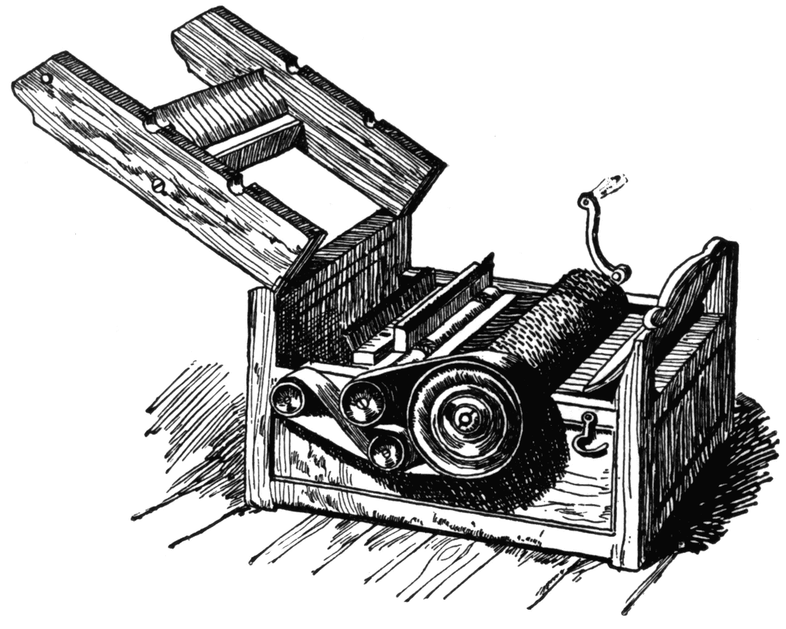
In hopes of making a patentable machine, Whitney put aside his plans to study law and instead tinkered throughout the winter and spring in a secret workshop provided by Catherine Greene. Within months he created the cotton gin. A small gin could be hand-cranked; larger versions could be harnessed to a horse or driven by water power. "One man and a horse will do more than fifty men with the old machines," wrote Whitney to his father. . . . "Tis generally said by those who know anything about it, that I shall make a Fortune by it."
But patenting an invention and making a profit from it are two different things. After considering possible options, Whitney and his business partner, Phineas Miller, opted to produce as many gins as possible, install them throughout Georgia and the South, and charge farmers a fee for doing the ginning for them. Their charge was two-fifths of the profit -- paid to them in cotton itself.
And here, all their troubles began. Farmers throughout Georgia resented having to go to Whitney's gins where they had to pay what they regarded as an exorbitant tax. __7__ planters began making their own versions of Whitney's gin and claiming they were "new" inventions. Miller brought costly suits against the owners of these pirated versions but because of a loophole in the wording of the 1793 patent act, they were unable to win any suits until 1800, when the law was changed.
Struggling to make a profit and mired in legal battles, the partners finally agreed to license gins at a reasonable price. In 1802 South Carolina agreed to purchase Whitney's patent right for $50,000 but delayed in paying it. The partners also arranged to sell the patent rights to North Carolina and Tennessee. By the time even the Georgia courts recognized the wrongs done to Whitney, only one year of his patent remained. In 1808 and again in 1812 he humbly petitioned Congress for a renewal of his patent.

The Effects of the Cotton Gin
After the invention of the cotton gin, the yield of raw cotton doubled each decade after 1800. Demand was fueled by other inventions of the Industrial Revolution, such as the machines to spin and weave it and the steamboat to transport it. By midcentury America was growing three-quarters of the world's supply of cotton, most of it shipped to England or New England where it was manufactured into cloth. During this time tobacco fell in value, rice exports at best stayed steady, and sugar began to thrive, but only in Louisiana. At midcentury the South provided three-fifths of America's exports -- most of it in cotton.
However, like many inventors, Whitney (who died in 1825) could not have foreseen the ways in which his invention would change society for the __10__. The most significant of these was the growth of slavery. While it was true that the cotton gin __11__ the labor of removing seeds, it did not reduce the need for slaves to grow and pick the cotton. In fact, the opposite occurred. Cotton growing became so profitable for the planters that it greatly increased their demand for both land and slave labor. In 1790 there were six slave states; in 1860 there were 15. From 1790 until Congress banned the importation of slaves from Africa in 1808, Southerners imported 80,000 Africans. By 1860 approximately one in three Southerners was a slave.
Because of the cotton gin, slaves now labored on ever-larger plantations where work was more regimented and relentless. As large plantations spread into the Southwest, the price of slaves and land inhibited the growth of cities and industries. In the 1850s seven-eighths of all immigrants settled in the North, where they found 72% of the nation's manufacturing capacity. The growth of the "peculiar institution" was affecting many aspects of Southern life.
Source: http://www.archives.gov/education/lessons/cotton-gin-patent/

Unit 2: Cotton Plantations assignment 2.2

Assignment 2.2 A: Read the text and answer the following questions.

- Fill in the missing word in line 5.
- find
- invent
- change
- see

- Why did Eli Whitney need a job according to lines 4-9?
____________________________________________________________________

- Whitney wanted to find a solution to a problem according to lines 10-18. What problem?
- That most cotton was grown along the coast.
- The sticky green seeds in the cotton.
- The time it took for cotton to grow.

- What was it that Whitney actually wanted to become?
____________________________________________________________________

- Where did Eli Whitney create his cotton gin?
____________________________________________________________________

- Why did the farmers throughout Georgia did not want to use Whitney’s cotton gin?
____________________________________________________________________

- Fill in the missing word in line 46.
- Instead
- Because
- Moreover
- However

- Whitney and Miller did not sell their patent rights to one of these states. Which one?
- North Carolina
- South Carolina
- Tennessee
- Alabama

- Name or describe at least two other inventions of the Industrial Revolution.
____________________________________________________________________
____________________________________________________________________

- Fill in the missing word in line 67.
- better
- worse

- Fill in the missing word in line 69.
- reduced
- increased
- stabilized
- aggravated

- How many percent of the Southerners was a slave according to this text?
- 25%
- 33%
- 66%
- 72%

